Corwin Connect
September 30, 2016

Identify and Focus on Essential Learning Outcomes
By Bob Sornson
At the beginning of the 2015-16 school year, preschool students in the Corinth-Alcorn-Prentiss Learning Collaborative were tested using the Star Early Literacy assessment as part of a state-wide assessment process. Only 20.1% of these children scored at or above a standard score of 498, the level associated with readiness for Kindergarten entry. By the end of the year, more than 85% of the students showed the literacy skills for K readiness.
This pattern of growth gave this collaborative in Northeast Mississippi the highest rate of kindergarten literacy readiness in the state. Student literacy readiness improved from an average scaled score of 434 in the fall to 597 in the spring, according to the MDE’s Preschool Assessment Result for Early Learning Collaboratives (2016).
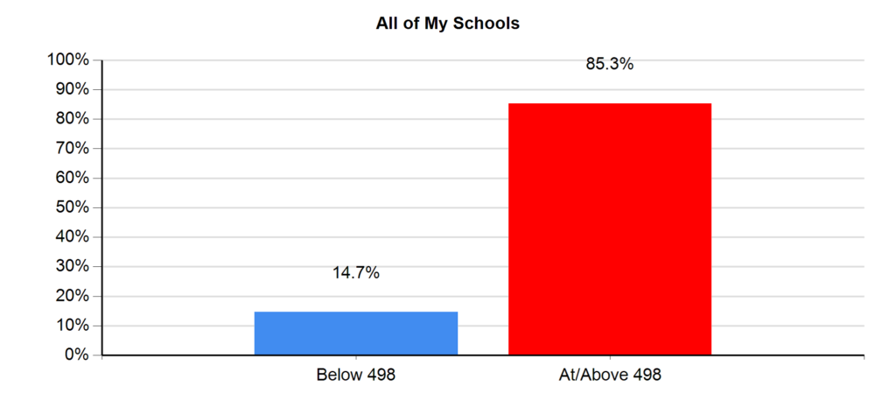
Figure 1: Corinth-Alcorn-Prentiss Learning Collaborative Student Rates of Literacy Readiness, 266 Students Tested, Fall to Spring, 2015-16
According to Tanya Nelson, Corinth School District Test Coordinator and Pre-K Director, the use of the Essential Skill Inventories (Sornson, 2012) and the application of the concepts of Competency Based Learning are responsible for giving staff a framework in which to build individual success.
Competency Based Learning is a design for instructional systems which is getting lots of attention in high school and university redesign across the nation and around the world. New Hampshire and Maine have replaced course and credit requirements with a requirement for specific competencies for high school graduation. But in this northeast Mississippi preschool collaborative, competency based learning is being used to improve outcomes for young students in communities with a high rate of poverty.
Competency Based Learning operates with a different set of ideas. In their first year of using the Essential Skill Inventories as a competency framework, teachers in the collaborative learned to:
- Clearly identify essential learning outcomes
- Use systematic measurement to determine the readiness levels of your students in relation to essential outcomes
- Offer responsive instruction until these skills/objectives are deeply understood
- Monitor progress until all essential learning is accomplished
- Allow students to move on to more advanced learning as soon as they are ready
This stands in contrast to most typical classrooms, in which staff are given long lists of content expectations and curriculum to cover, pacing guides to keep them moving, and assessments to give kids scores, effectively sorting children into winners and losers, even in the early years of school.
The Essential Skill Inventories (PreK-3) are a competency framework which helps teachers systematically monitor progress towards the crucial skills which young children need to learn well. At each grade level there are 30 to 40 skills which are essential to long-term learning success, and include oral language, sensory-motor skills, self-regulation and behavior, literacy, numeracy, phonologic skills, and self-help skills. These are the skills which need more than “coverage.” The inventories help staff track the progress of each student toward these essential skills, and help teachers build instructional plans that allow for learning activities that match student readiness and tier toward competency in each crucial domain of early childhood development.
Ms. Nelson explained, “Before implementing Essential Skills Inventories, teachers used an academic screener that gave them a general idea of where students were academically, but did not give them information about specific developmental gaps that affect learning. In the old model, children were grouped by ability for teacher directed instruction. Teachers had a general idea of where their children would perform on end of year assessments. They could not tell you exactly where each child was developmentally, and how those developmental gaps affected their academic performance.”
She continued, “Our prekindergarten teachers state that using the Essential Skills Inventory has helped them get to know their students as individuals for the first time. They know exactly what each child can or cannot do. They also have new information about motor skills, visual acuity, and behavior. The depth at which they know their students enables them to plan appropriate rigor and scaffold learning for the children to be able to meet the grade level expectation by the end of the year. Teachers are acutely aware of their students’ abilities, and they are constantly looking for examples of children meeting milestones through independent free choice centers, on the playground, etc.”
To use this new framework effectively, the collaborative followed these steps:
- Staff in the Corinth-Alcorn-Prentiss Learning Collaborative received training to help them understand each essential grade level skill, how to use the rubrics which describe proficiency, and how to systematically track progress for each student.
- Teachers attended a weekly data review meeting to review plans to assess two domains of instruction each week, and to share ideas for both assessment and instructional planning based on the needs of their students.
- With a deep understanding of each student’s skills, teachers offered instruction matched to student readiness, for as long as needed to achieve full competency for each essential skill.
The use of a competency framework allowed these early childhood educators to identify which skills are essential to long-term learning success, and to stay focused on the needs of each child. In the first year of implementation, they were able to understand their students’ learning needs more specifically and deliver instruction that matched student instructional levels. As a result, students in this northeast Mississippi collaborative have the highest levels of literacy readiness in the state.

References
Sornson, B. (2012). Fanatically Formative: Successful Learning during the Crucial K-3 Years, Thousand Oaks, CA: Corwin Press.
Sornson, B. (2012). Essential Skill Inventories Pre-K to Grade 3, Brighton, MI: Early Learning Foundation. http://earlylearningfoundation.com/portfolio/educators/
Sornson, B. (2014). Essential Math Skills, Huntington Beach, CA: Shell Education.
Sornson, B. (2016). Over-Tested and Under-Prepared: Using Competency Based Learning to Transform Our Schools,New York: Routledge.

BOB SORNSON
Bob Sornson is an award-winning author and presenter, calling for programs and practices which support competency based learning and early learning success. He works internationally with school districts, universities, and parent organizations. His many books include Over-Tested and Under-Prepared: Using Competency-Based Learning to Transform Our Schools(Routledge), Fanatically Formative (Corwin Press), and Stand in My Shoes: Kids Learning about Empathy (Love and Logic Press). Contact Bob@earlylearningfoundation.com.

